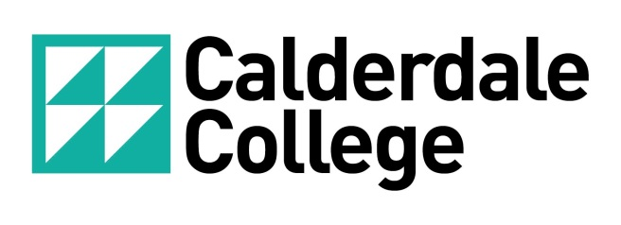

**DISTANCE & BLENDED LEARNING POLICY**

**AUTHOR: Quality Manager**

**DATE: May 2024**

**VERSION 4**

Table of Contents

1. Purpose 3

2. scope 3

3. Details of policy 3

4. Monitoring 3

5. Related policies/procedures/documents 3

6. Policy review 4

7. EQUALITY IMPACT ASSESSMENT 4

8. Publication 4

# Purpose

The aim of the policy is to ensure:

* Calderdale College is compliant with distance and/or blended learning guidelines set out by Awarding Organisations
* Assessment methods used in conjunction with distance and/or blended learning are valid, reliable and do not disadvantage any learners.

# Scope

The policy is relevant to all Calderdale College provision that uses distance and/or blended learning as part of teaching, learning and assessment.

# Details of policy

In relation to distance and blended learning, Calderdale College will:

* Ensure that staff involved in teaching, learning and assessment are timetabled appropriately to enable support to be provided to learners who are working remotely.
* Ensure that there is a process to manage feedback on assignments, that questions from learners are answered appropriately and that feedback is provided in a timely manner.
* Ensure that the setting of assignments is undertaken in face-to-face sessions and that deadlines are clear to learners.
* Ensure that when learners submit work appropriate measures are taken to ensure that work is authentic and has been completed by the learner.
* Maintain and store securely all assessment and internal verification records in accordance with relevant Awarding Organisation guidelines.

# Monitoring

Compliance to this policy will be monitored through the internal and external verification processes.

# Related policies/procedures/documents

* Assessment Policy
* Internal Assessment & Verification Procedure
* External Assessment & Verification Procedure
* Malpractice & Maladministration Policy
* Staff Code of Conduct & Malpractice Policy
* Examination & Assessment Concession Policy
* Learner Assessment Appeals Policy
* Single Equality Scheme

# Policy review

|  |  |
| --- | --- |
| **Change(s) Made** | **Reason for Change** |
| Role title change Quality Systems Manager to Quality Manager | Role title change |

|  |  |  |  |  |  |
| --- | --- | --- | --- | --- | --- |
| **Review Date** | **Reviewed by:** | **Initial Approval by:** | **Final Approval by:** | **Next Review Date:** | **Review Period** |
| 05.2024 | Quality Manager | Quality Manager |  | May 2025 | 1 year |

# Equality Impact Assessment

|  |  |  |  |
| --- | --- | --- | --- |
| **First Assessment Conducted by:** | **Date:** | **Final/Approved Assessment Conducted by:** | **Date:** |
| Quality Systems Manager | 11.2020 | Quality Systems Manager | 11.2020 |

# Publication

|  |  |
| --- | --- |
| **Audience:** | **Published:** |
| Staff | Staff Intranet |